This document provides a comprehensive introduction to the Awesome-Deep-Learning-For-Machine-Vision repository, a collection of optimized machine vision approaches primarily focused on deep learning applications. The repository hosts several independent projects that showcase different techniques and implementations in the field of computer vision.

**Repository Overview**

The repository contains four major machine vision projects, each exploring different aspects of deep learning for visual perception:

1. **ZYNQ CNN**: Hardware-accelerated CNN implementation on FPGA for handwritten digit recognition
2. **VisionRC**: Bio-inspired network combining Reservoir Computing, Graph Neural Networks, and deep learning
3. **MMactionForSF**: Action recognition system using SlowFast network architecture
4. **Deep SORT**: Enhanced object tracking system using YOLO and SORT algorithms

**Technology overview**

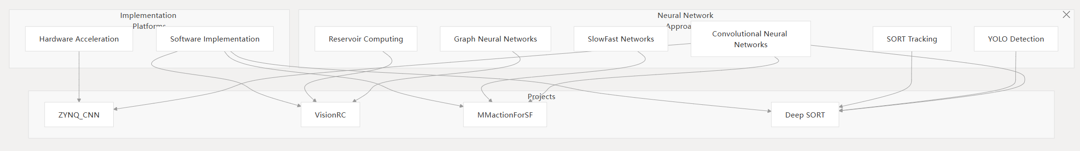

**Figure 1**

The repository contains three primary systems, each focusing on different aspects of computer vision:

Table1

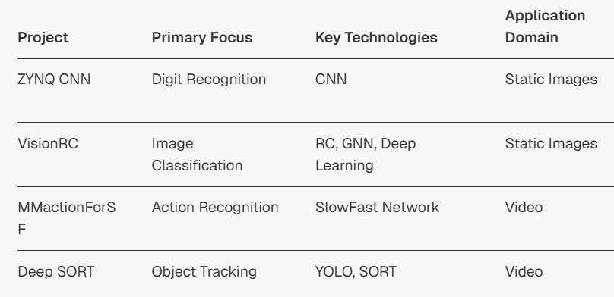

**Main Components**

**ZYNQ CNN Implementation**

The ZYNQ CNN project implements a convolutional neural network on FPGA hardware for real-time handwritten digit recognition (0-9). This project demonstrates hardware acceleration of deep learning models for improved performance.

**VisionRC**

VisionRC is a bio-inspired network that combines Reservoir Computing (RC), Graph Neural Networks (GNN), and traditional deep learning approaches for image recognition. Key features include:

The ResGraph mechanism, which integrates reservoir computing with graph processing

Support for both isotropic (ViT-inspired) and pyramid (CNN-inspired) architectures

Bio-inspired computational principles that aim for efficient visual processing

**MMactionForSF**

MMactionForSF is a dual-stream spatiotemporal architecture that utilizes the SlowFast network for human action recognition. The system processes video inputs through two pathways:

* A Slow pathway that captures spatial details with high channel capacity but low temporal resolution
* A Fast pathway that captures motion information with high temporal resolution but lower channel capacity

This dual-pathway approach enables effective processing of both spatial and temporal information in videos, making it particularly suitable for human action recognition tasks.

**Deep SORT**

Deep SORT (Simple Online and Realtime Tracking with Deep Learning) enhances the original SORT tracking algorithm with deep learning approaches, particularly YOLOv3. The system combines:

Object detection using YOLOv3

Visual appearance features extracted via a Siamese network

Motion prediction using Kalman filtering

Data association techniques for matching detections to existing tracks

These enhancements improve tracking performance in complex environments with occlusions, similar-looking objects, and varying lighting conditions.

This system represents a novel approach to machine vision that draws inspiration from biological visual systems.

**System Integration Potential**

While the three systems are implemented as separate projects, they could theoretically be integrated into a comprehensive machine vision pipeline. The following diagram illustrates this potential integration:

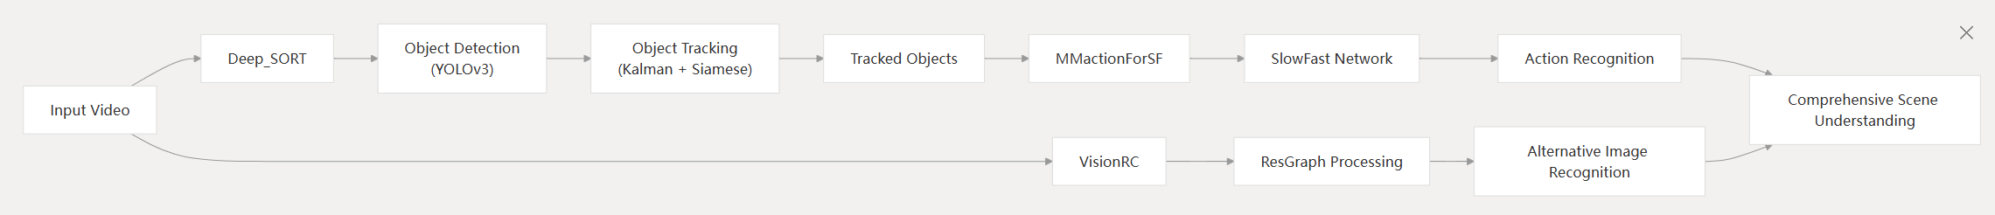

**Figure2**

In this potential integration:

1. ZYNQ would implement a low-power embedded handwritten digit recognition system on the ZYNQ-7020 SoC platform, integrating camera image acquisition, convolutional neural network inference, and HDMI display output functionality.
2. VisionRC could provide an alternative pathway for image recognition
3. MMactionForSF would recognize actions performed by the tracked objects
4. Deep SORT would handle object detection and tracking in video streams

Such an integrated system would enable comprehensive scene understanding by combining object tracking, action recognition, and general image recognition capabilities.

**Conclusion**

Each system directory contains the implementation code, configuration files, and utilities needed to run the respective system. The repository follows a modular structure, allowing each system to be studied, used, or modified independently.